**Coding scheme**

1. **Action**

1_1 not do action

1_2 alternative action

**Epistemic state**

2_1 just epistemic state change *2*

2_2 by reading *132*

2_3 by external change in e-mail system *0*

2_4 epistemic state change by so else (includes informing others, or agent) *4*

2_5 epistemic state change by other, additional action of agent (including preventing setting) *3*

2_6 epistemic state about bug

2_7 had checked spam-folder (not includedO

**4 – environment** *2*

4_1 modification/different behaviour of agent/object acted on, receiver

4_2 changes in actions by someone else (prior to the outcome) to prevent the problem

4_3 modifications in item used

4_4 changes in epistemic change of someone else

Small categories: direct epistemic state change

Epistemic state about default

e-mail

Conclusion:

EP change by the action of the agent: by reading, by addition action

EP change without direct control of agent: by some other agent, by technical fix

Where to put just direct change?

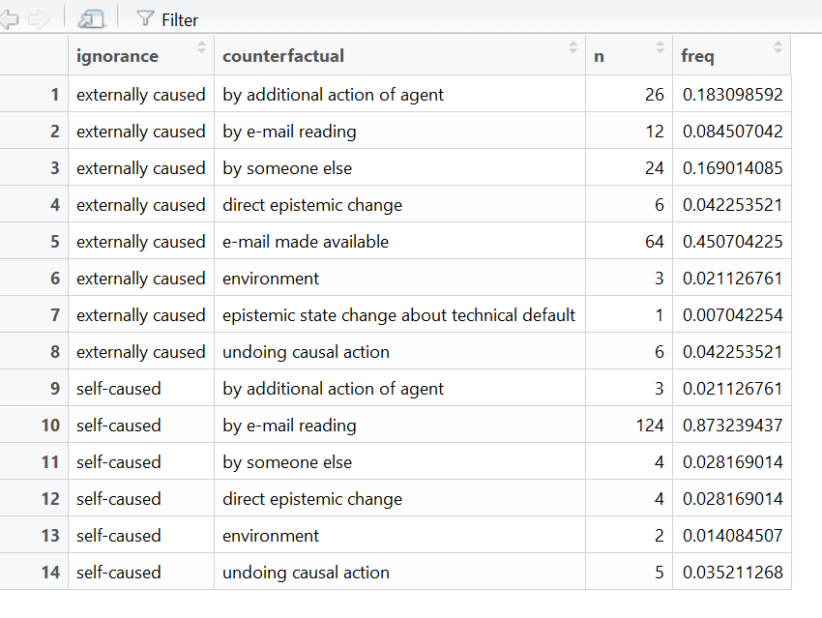

Questions:

How to treat reading e-mail in externally caused condition?

How do we define ease of manipulation? How do we want to set categories here…